DBMS LAB2
Anmol Keswani_ECS_D6-68
Aim: To design and implement a relational database system using DBMS concepts by creating database schemas, defining tables and relationships , populating data, and executing SQL queries for efficient data retrieval ans analysis.
Create a database for ODI cricket. Refer Schema given below.
1. Create database & tables
CREATE DATABASE stud1_match;
USE stud1_match;
create table ODIMatch (
MatchID int unsigned,
Team1 varchar(15),
Team2 varchar(15),
Ground varchar(20),
Date date,
Winner varchar(10),
PRIMARY KEY (MatchID));
insert into ODIMatch (MatchID,Team1,Team2,Ground,Date,Winner) values (2324,'Pakistan','India','Peshwar','2006-2-6','Team1');
insert into ODIMatch (MatchID,Team1,Team2,Ground,Date,Winner) values (2327,'Pakistan','India','Rawalpindi','2006-2-11','Team2');
insert into ODIMatch (MatchID,Team1,Team2,Ground,Date,Winner) values (2357,'India','England','Delhi','2006-3-28','Team1');
insert into ODIMatch (MatchID,Team1,Team2,Ground,Date,Winner) values (2377,'West Indies','India','Kingston','2006-5-18','Team2');
insert into ODIMatch (MatchID,Team1,Team2,Ground,Date,Winner) values (2404,'Sri Lanka','India','Colombo','2006-8-16','Abandoned');
insert into ODIMatch (MatchID,Team1,Team2,Ground,Date,Winner) values (2440,'India','Australia','Mohali','2006-10-29','Team2');
insert into ODIMatch values (2449,'South Africa','India','Cape Town','2006-11-26','Team1');
insert into ODIMatch values (2480,'India','West Indies','Nagpur','2007-1-21','Team1');
insert into ODIMatch values (2493,'India','west Indies','Vadodara','2007-1-31','Team1');
insert into ODIMatch values (2520,'India','Sri Lanka','Rajkot','2007-2-11','Team2');
insert into ODIMatch values (2611,'England','India','Southampton','2007-8-21','Team1');
insert into ODIMatch values (2632,'India','Australia','Mumbai','2007-10-17','Team1');
insert into ODIMatch values (2643,'India','Pakistan','Guwahati','2007-11-5','Team1'),
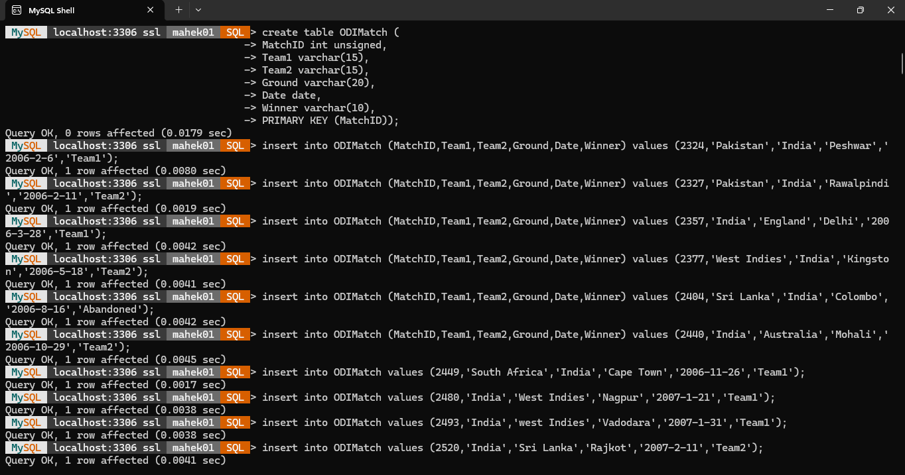

(2675,'Australia','India','Melbourne','2008-2-10','Team2'),
(2681,'India','Sri Lanka','Adelaide','2008-2-19','Team1'),
(2688,'Australia','India','Sydney','2008-3-2','Team2'),
(2689,'Australia','India','Brisbane','2008-3-4','Team2'),
(2717,'Pakistan','India','Karachi','2008-6-26','Team2'),
(2750,'Sri Lanka','India','Colombo','2008-8-24','Team2'),
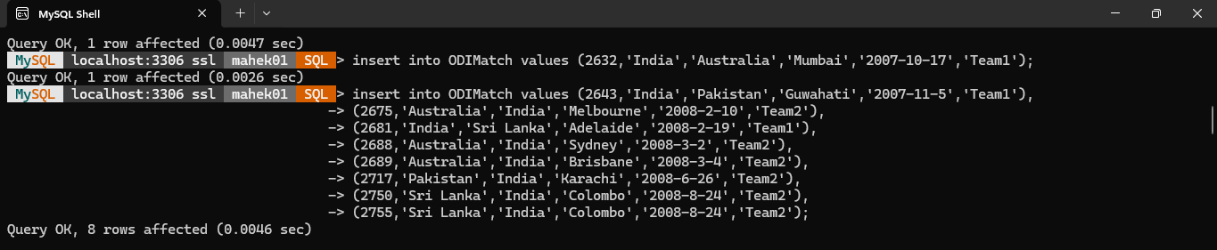
(2755,'Sri Lanka','India','Colombo','2008-8-24','Team2');

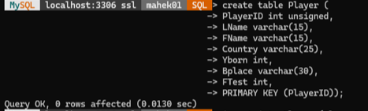
create table Player (
PlayerID int unsigned,
LName varchar(15),
FName varchar(15),
Country varchar(25),
Yborn int,
Bplace varchar(30),
FTest int,
PRIMARY KEY (PlayerID));
insert into Player (PlayerID,Lname,Fname,Country,Yborn,Bplace,Ftest) values (89001,'Tendulkar','Sachin','India',1973,'Mumbai',1989);
insert into Player (PlayerID,Lname,Fname,Country,Yborn,Bplace,Ftest) values (90001,'Lara','Brain','West Indies',1969,'Santa Cruz',1990);
insert into Player (PlayerID,Lname,Fname,Country,Yborn,Bplace,Ftest) values (95001,'Ponting','Ricky','Australia',1974,'Launceston',1995);
insert into Player (PlayerID,Lname,Fname,Country,Yborn,Bplace,Ftest) values (96001,'Dravid','Rahul','India',1973,'Indore',1996);
insert into Player values (96002,'Gibbs','Herschelle','South Africa',1974,'Cape Town',1996),
(92001,'Warne','Shane','Australia',1969,'Melbourne',1992),
(95002,'Pollock','Shaun','South Africa',1973,'Port Elizabeth',1995),
(99003,'Vaughan','Michale','England',1974,'Manchester',1999),
(92003,'UI-Huq','Inzamam','Pakistan',1970,'Multan',1992),
(94004,'Fleming','Stephen','New Zealand',1973,'Christchurch',1994),
(93002,'Streak','Heath','Zimbabwe',1974,'Bulawayo',1993),
(90002,'Kumble','Anil','India',1970,'Bangalore',1990),
(93003,'Kirsten','Gary','South Africa',1967,'Cape Town',1993),
(95003,'Kallis','Jacques','South Africa',1975,'Cape Town',1995),
(94002,'Vaas','Chaminda','Sri Lanka',1974,'Mattumagala',1994),
(92002,'Murlitharan','Muthiah','Sri Lanka',1972,'Kandy',1992),
(97004,'Vettori','Daniel','New Zealand',1979,'Auckland',1997),
(25001,'Dhoni','MS','India',1981,'Ranchi',2005),
(23001,'Singh','Yuvraj','India',1981,'Chandigarh',2003),
(96003,'Ganguly','Saurav','India',1972,'Calcutta',1996),
(99002,'Gilchrist','Adam','Australia',1971,'Bellingen',1999),
(24001,'Symonds','Andrew','Australia',1975,'Birmingham',2004),
(99001,'Lee','Breet','Australia',1976,'Wollongong',1999),
(91001,'Jayasuriya','Sanath','Sri Lanka',1969,'Matara',1991),
(21001,'Sehwag','Virender','India',1978,'Delhi',2001),
(98001,'Afridi','Shahid','Pakistan',1980,'Khyber Agency',1998),
(98002,'Singh','Harbhajan','India',1980,'Jalandhar',1998),
(27002,'Sharma','Ishant','India',1988,'Delhi',2007);
insert into Player (PlayerID,Lname,Fname,Country,Yborn,Bplace) values (27001,'Kumar','Praveen','India',1986,'Meerut');
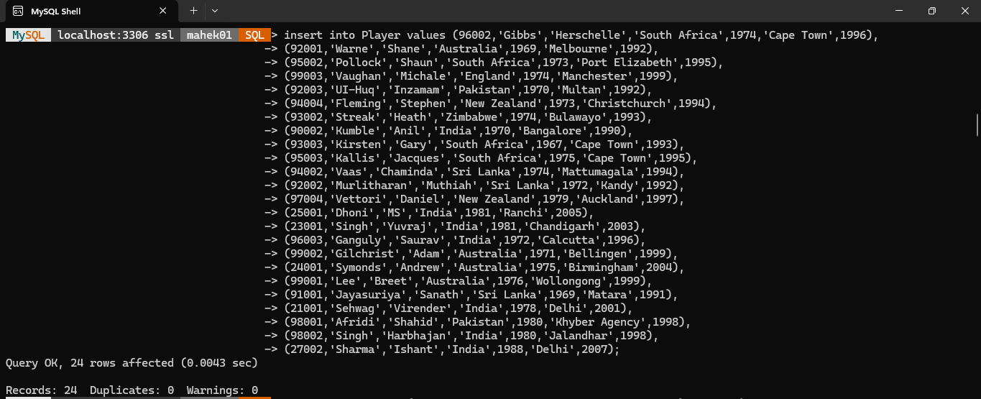

CREATE TABLE Batting (
MatchID INT UNSIGNED,
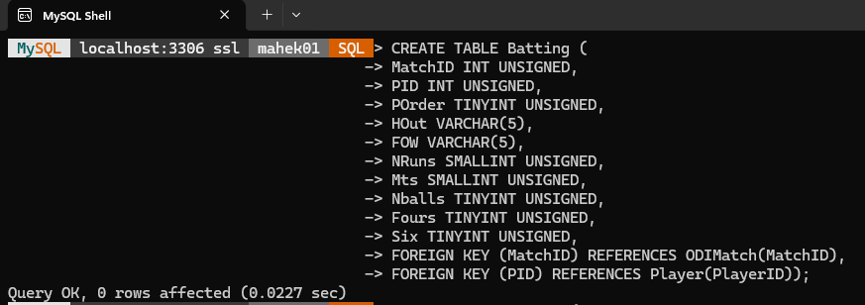
PID INT UNSIGNED,
POrder TINYINT UNSIGNED,
HOut VARCHAR(5),
FOW VARCHAR(5),
NRuns SMALLINT UNSIGNED,
Mts SMALLINT UNSIGNED,
Nballs TINYINT UNSIGNED,
Fours TINYINT UNSIGNED,
Six TINYINT UNSIGNED,
FOREIGN KEY (MatchID) REFERENCES ODIMatch(MatchID),
FOREIGN KEY (PID) REFERENCES Player(PlayerID));
INSERT INTO Batting (MatchID,PID,POrder,Hout,FOW,Nruns,Mts,Nballs,Fours,Six) VALUES (2755,23001,3,'C',51,0,12,6,0,0);
INSERT INTO Batting (MatchID,PID,POrder,Hout,FOW,Nruns,Mts,Nballs,Fours,Six) VALUES (2755,25001,5,'C',232,71,104,80,4,0);
INSERT INTO Batting (MatchID,PID,POrder,Hout,FOW,Nruns,Mts,Nballs,Fours,Six) VALUES (2755,91001,1,'C',74,60,85,52,8,2);
INSERT INTO Batting VALUES (2755,94002,7,'LBW',157,17,23,29,1,0),
(2755,92002,11,'NO','NO',1,11,7,0,0),
(2689,89001,2,'C',205,91,176,121,7,0),
(2689,23001,4,'C',175,38,27,38,2,2),
(2689,25001,5,'C',240,36,52,37,2,1),
(2689,99002,1,'C',2,2,3,3,0,0),
(2689,95001,3,'C',8,1,9,7,0,0),
(2689,24001,5,'C',123,42,81,56,2,1),
(2689,99001,8,'B',228,7,20,12,0,0),
(2689,27001,9,'C',255,7,7,7,1,0),
(2755,27001,9,'B',257,2,7,6,0,0),
(2689,98002,8,'LBW',249,3,7,3,0,0),
(2755,98002,8,'RO',253,2,7,4,0,0);
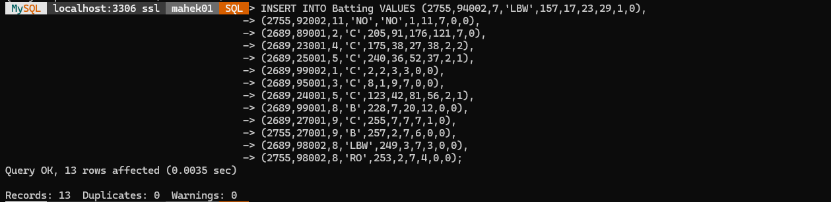
CREATE TABLE Bowling (
MatchID INT UNSIGNED,
PID INT UNSIGNED,
NOvers TINYINT UNSIGNED,
Maidens TINYINT UNSIGNED,
Nruns SMALLINT UNSIGNED ,
Nwickets TINYINT UNSIGNED,
FOREIGN KEY (MatchID) REFERENCES ODIMatch(MatchID),
FOREIGN KEY (PID) REFERENCES Player(PlayerID));
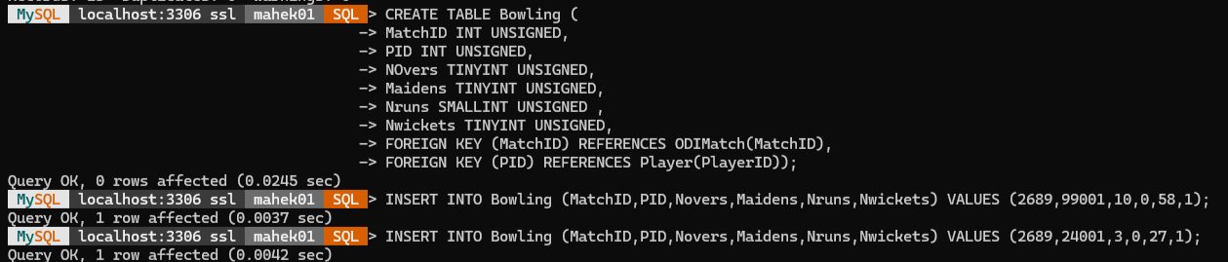
INSERT INTO Bowling (MatchID,PID,Novers,Maidens,Nruns,Nwickets) VALUES (2689,99001,10,0,58,1);
INSERT INTO Bowling (MatchID,PID,Novers,Maidens,Nruns,Nwickets) VALUES (2689,24001,3,0,27,1);
INSERT INTO Bowling VALUES (2689,23001,3,0,15,0),
(2755,94002,9,1,40,1),
(2755,92002,10,0,56,1),
(2755,91001,4,0,29,0),
(2755,23001,10,0,53,2),
(2755,98002,10,0,40,3),
(2689,98002,10,0,44,1);
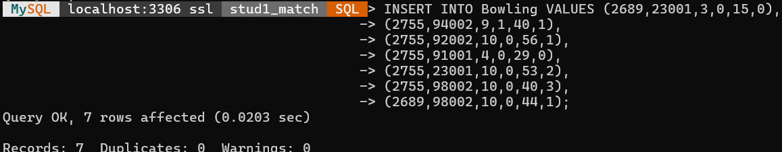

2. Display description of each table
Describe ODIMatch;
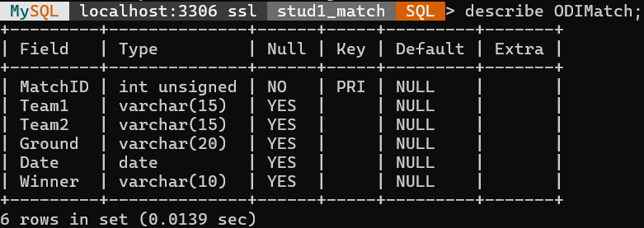

Describe Player;
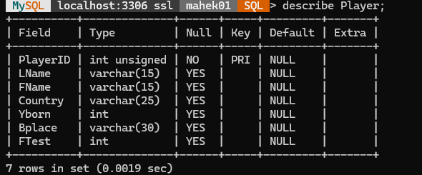
Describe Bowling;
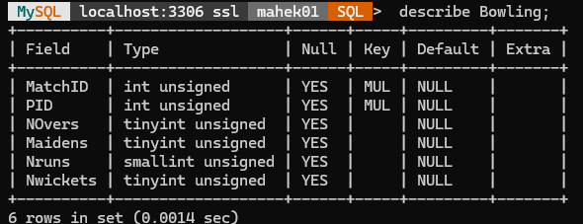
Describe Batting;
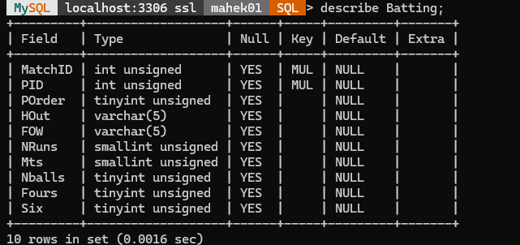

Q1a. Print ODIMatch table.
mysql> select * from ODIMatch;

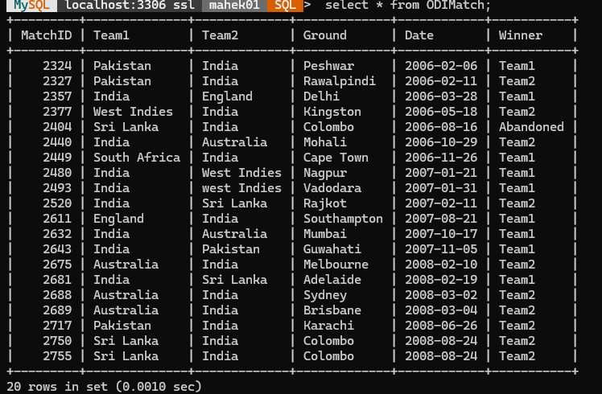
Q1b. Print Player table.
mysql> select * from Player;
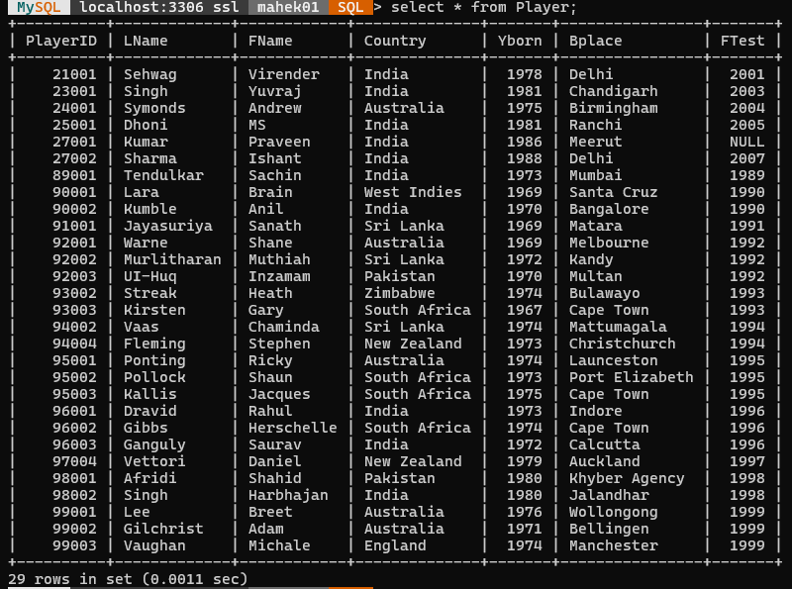
Q1c. Print Bowling table.
mysql> select * from Bowling;
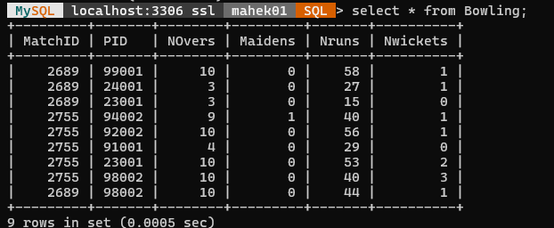
Q1d. Print Batting table.
mysql> select * from Batting;
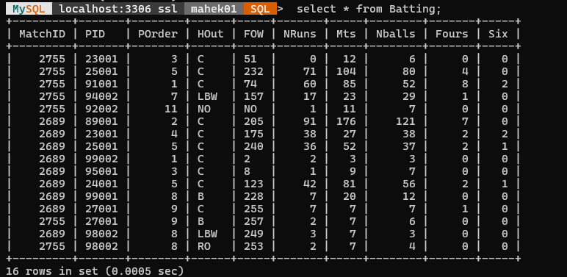
Q2. Find the Ids, First name, Last name as Surname of all cricket players.
mysql> select PlayerID,Fname,Lname as Surname from Player;
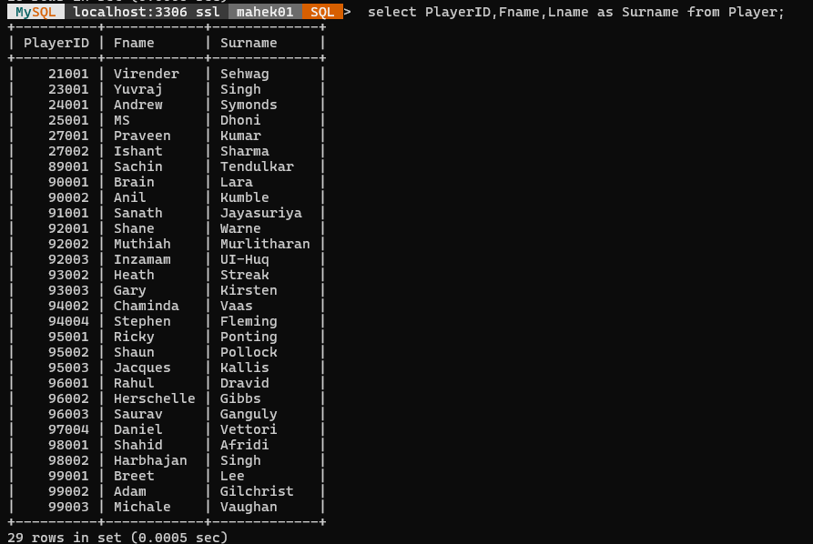
Q3a. Find all the information from table Player about players from India.
mysql> select * from Player where Country='India';
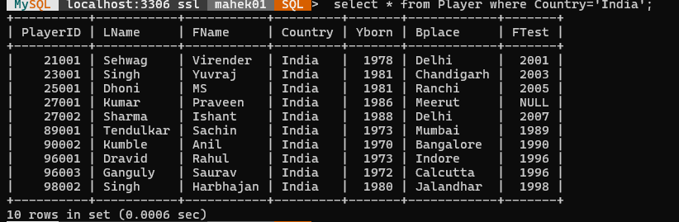
Q3b. Find the player Ids, First name & birth place of Indian cricket players.
mysql> select PlayerID,Fname,Bplace from Player where Country='India';
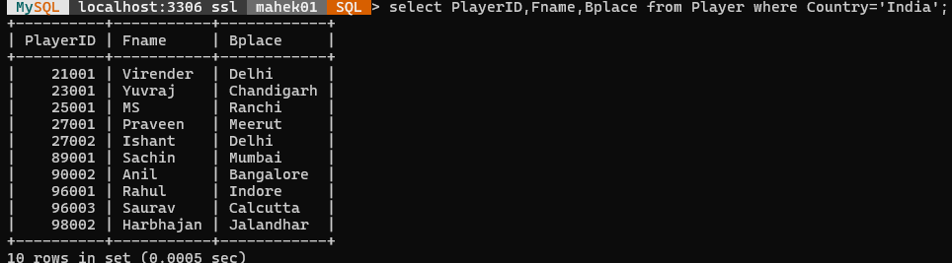

Q4. Find all the information from table Player about players from India who were born after 1980
mysql> select * from Player where Country='India' and Yborn > 1980;
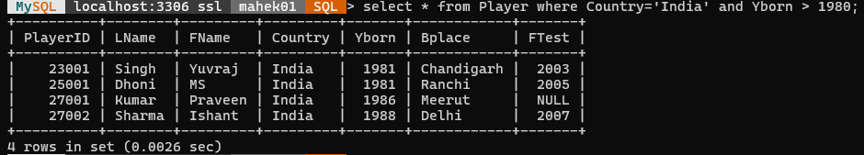
Q5. Find the details of all matches played by Pakistan
mysql> SELECT * FROM ODIMatch WHERE Team1='Pakistan' OR Team2='Pakistan';
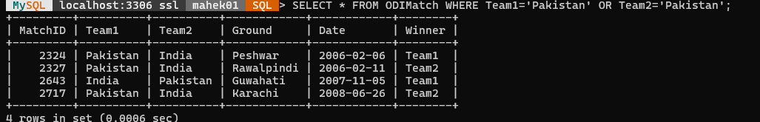
Q6a. Find the details of all matches played by India as a Second team.
mysql> SELECT * FROM ODIMatch WHERE Team2='India';
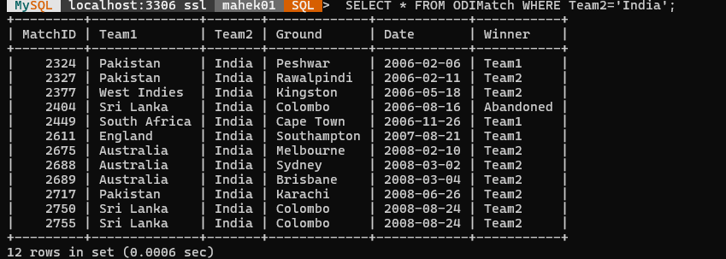
Q6b. Find the details of all matches played by India or Australia as Team1.
mysql> SELECT * FROM ODIMatch WHERE Team1='Australia' OR Team1='India';
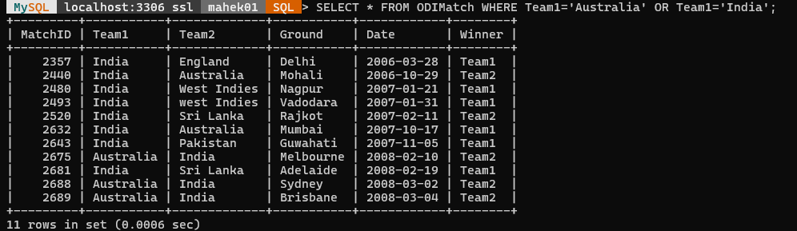

mysql> SELECT * FROM ODIMatch WHERE Team1 IN ('Australia','India');
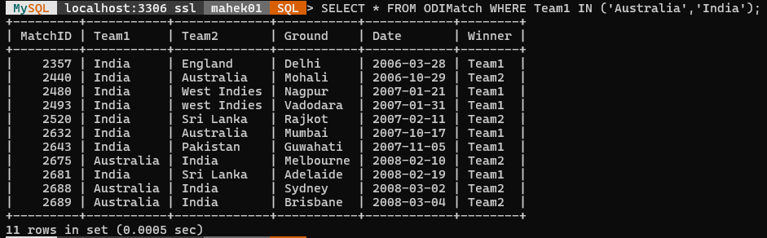
Q6c. Find the match details Team2, Winner & ground in which India won the toss
(assume Team1 is toss winner)
mysql> SELECT Team2,Winner,Ground FROM ODIMatch WHERE Team1 = 'India';
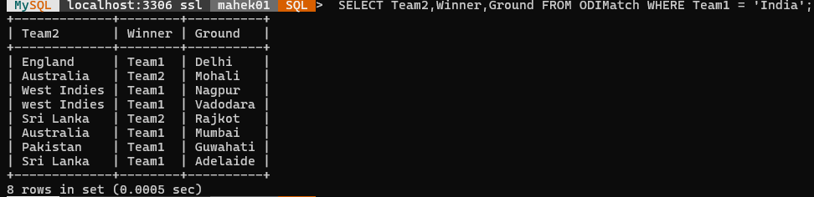
Q7. Find Ids of all players that have bowled in an ODI match in the database
mysql> SELECT DISTINCT PID FROM Bowling;
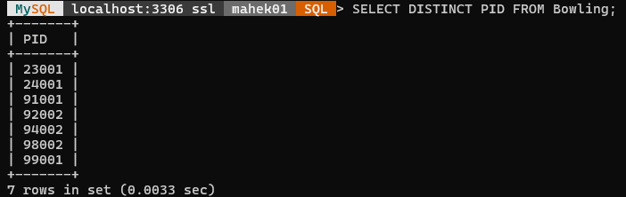
Q8. Find names of teams and grounds where India has played an ODI match outside India. (assume Team1 is the host country)
mysql> SELECT DISTINCT Team1,Ground FROM ODIMatch WHERE Team2='India';
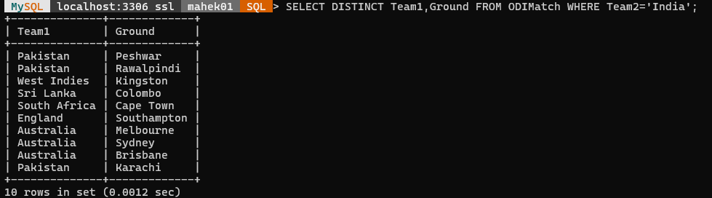
Q9. Find Ids of all players that batted in match 2755
mysql> SELECT PID FROM Batting WHERE MatchID=2755;
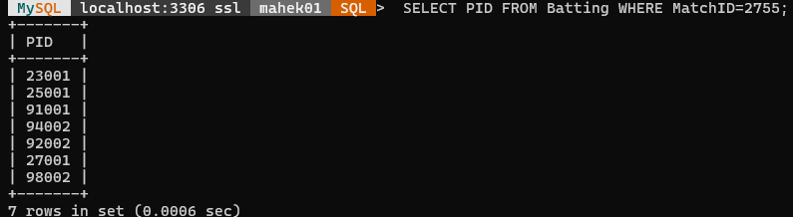
Q10a. Display list of ground names where Australia has played as Team1
mysql> SELECT Ground FROM ODIMatch WHERE Team1='Australia';
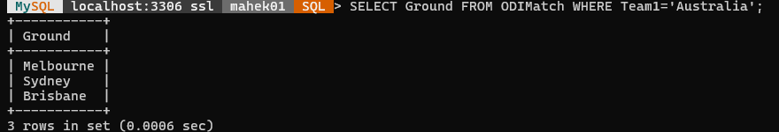
Q10b. Display sorted list of ground names where Australia has played as Team1
mysql> SELECT Ground FROM ODIMatch WHERE Team1='Australia' ORDER BY Ground;
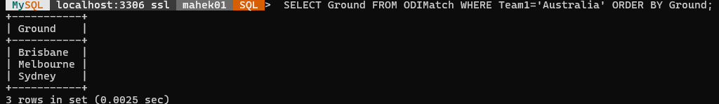
Q11. Find name of all players whose last name starts with Sin
mysql> SELECT Fname,Lname FROM Player WHERE Lname LIKE 'Sin%';
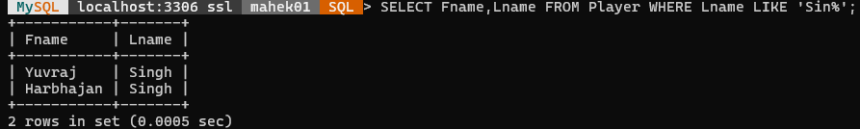
Q12. Find Ids, First name of all players who played in match 2755.
mysql> SELECT PlayerID,Fname FROM Player WHERE PlayerID IN (SELECT PID FROM Batting WHERE MatchID=2755);
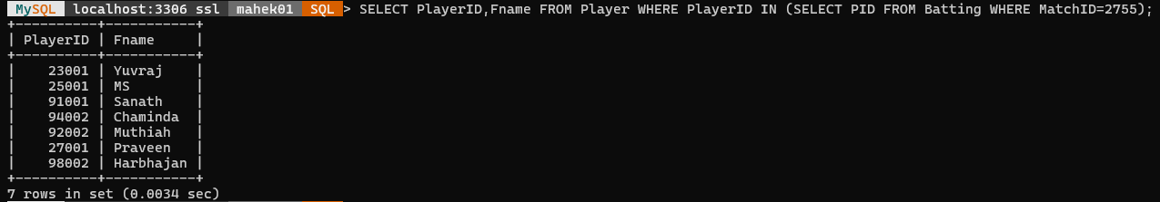
Q13. Find match Ids of all matches in which Tendulkar batted.
mysql> SELECT MatchID FROM Batting WHERE PID IN (SELECT PlayerID FROM Player WHERE Lname='Tendulkar');
Q14. Find match information of all matches in which dhoni has batted.
mysql> SELECT MatchID,Team1,Team2,Ground,Date FROM ODIMatch WHERE MatchID IN (SELECT MatchID FROM Batting WHERE PID IN(SELECT PlayerID FROM Player WHERE Lname='Dhoni'));
